**INTRODUCTION:**

# UNIT 2

The Internet is a combination of networks glued together by connecting devices (routers or switches). If a packet is to travel from a host to another host, it needs to pass through these networks.

Communication at the data-link layer is made up of five separate logical connections between the data-link layers in the path.

## NODES AND LINKS:

Communication at the data-link layer is node-to-node. A data unit from one point in the Internet needs to pass through many networks (LANs and WANs) to reach another point.

Theses LANs and WANs are connected by routers. It is customary to refer to the two end hosts and the routers as ***nodes*** and the networks in between as ***links*.** Figure 2.1 is a simple representation of links and nodes when the path of the data unit is only six nodes.

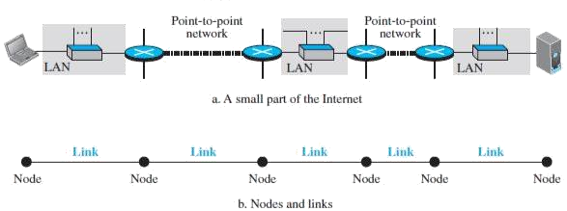

## FIGURE 2.1: NODES AND LINKS

The first node is the source host; the last node is the destination host. The other four nodes are four routers. The first, the third, and the fifth links represent the three LANs; the second and the fourth links represent the two WANs.

## Services:

The data-link layer is located between the physical and the network layers. The data link layer provides services to the network layer; it receives services from the physical layer.

The duty scope of the data-link layer is node-to-node. When a packet is travelling in the Internet, the data-link layer of a node (host or router) is responsible for delivering a datagram to the next node in the path.

For this purpose, the data-link layer of the sending node needs to encapsulate the datagram received from the network in a frame, and the data-link layer of the receiving node needs to decapsulate the datagram from the frame.

In other words, the data-link layer of the source host needs only to encapsulate, the data-link layer of the destination host needs to decapsulate, but each intermediate node needs to both encapsulate and decapsulate. We can list the services provided by a data-link layer as shown below.

***FRAMING:*** Definitely, the first service provided by the data-link layer is **framing**. The data-link layer at each node needs to encapsulate the datagram (packet received from the network layer) in a **frame** before sending it to the next node. The node also needs to decapsulate the datagram from the frame received on the logical channel.

***FLOW CONTROL:*** The sending data-link layer at the end of a link is a producer of frames; the receiving data-link layer at the other end of a link is a consumer.

If the rate of produced frames is higher than the rate of consumed frames, frames at the receiving end need to be buffered while waiting to be consumed (processed). Definitely, we cannot have an unlimited buffer size at the receiving side. We have two choices. The first choice is to let the receiving data-link layer drop the frames if its buffer is full.

The second choice is to let the receiving data-link layer send a feedback to the sending data-link layer to ask it to stop or slow down. Different data-link-layer protocols use different strategies for flow control.

***ERROR CONTROL:*** At the sending node, a frame in a data-link layer needs to be changed to bits, transformed to electromagnetic signals, and transmitted through the transmission media. At the receiving node, electromagnetic signals are received, transformed to bits, and put together to create a frame.

Since electromagnetic signals are susceptible to error, a frame is susceptible to error. The error needs first to be detected. After detection, it needs to be either corrected at the receiver node or discarded and retransmitted by the sending node.

***CONGESTION CONTROL:*** Although a link may be congested with frames, which may result in frame loss, most data-link-layer protocols do not directly use a congestion control to alleviate congestion, although some wide-area networks do.

In general, congestion control is considered an issue in the network layer or the transport layer because of its end-to-end nature.

**Two categories of links:** We can have a data-link layer that uses the whole capacity of the medium; we can also have a data-link layer that uses only part of the capacity of the link.

In other words, we can have a *point-to-point link* or a *broadcast link*. In a point-to-point link, the link is dedicated to the two devices; in a broadcast link, the link is shared between several pairs of devices.

## Two Sub layers:

To better understand the functionality of and the services provided by the link layer, we can divide the data-link layer into two sub layers: **data link control (DLC)** and **media access control (MAC).**

The data link control sub layer deals with all issues common to both point-to- point and broadcast links; the media access control sub layer deals only with issues specific to broadcast links.

## LINK-LAYER ADDRESSING:

A *link-layer address* is sometimes called a *link address*, sometimes a *physical address*, and sometimes a *MAC address.*

Since a link is controlled at the data-link layer, the addresses need to belong to the data-link layer. When a datagram passes from the network layer to the data-link layer, the datagram will be encapsulated in a frame and two data-link

addresses are added to the frame header. These two addresses are changed every time the frame moves from one link to another.

## Three types of addresses:

Some link-layer protocols define three types of addresses: unicast, multicast, and broadcast.

***Unicast Address:*** Each host or each interface of a router is assigned a unicast address. Unicasting means one-to-one communication.

***Multicast Address:*** Some link-layer protocols define multicast addresses.

Multicasting means one-to-many communication.

***Broadcast Address:*** Some link-layer protocols define a broadcast address. Broadcasting means one-to-all communication. A frame with a destination broadcast address is sent to all entities in the link.

## Address Resolution Protocol (ARP):

Anytime a node has an IP datagram to send to another node in a link, it has the IP address of the receiving node. The source host knows the IP address of the default router.

Each router except the last one in the path gets the IP address of the next router by using its forwarding table. The last router knows the IP address of the destination host.

However, the IP address of the next node is not helpful in moving a frame through a link; we need the link-layer address of the next node. This is the time when the **Address Resolution Protocol (ARP)** becomes helpful.

The ARP protocol is one of the auxiliary protocols defined in the network layer. It belongs to the network layer, but we discuss it here because it maps an IP address to a logical-link address. ARP accepts an IP address from the IP protocol, maps the address to the corresponding link-layer address, and passes it to the data-link layer.

Anytime a host or a router needs to find the link-layer address of another host or router in its network, it sends an ARP request packet. The packet includes the link-layer and IP addresses of the sender and the IP address of the receiver. Because the sender does not know the link-layer address of the receiver, the query is broadcast over the link using the link-layer broadcast address.

Every host or router on the network receives and processes the ARP request packet, but only the intended recipient recognizes its IP address and sends back an ARP response packet. The response packet contains the recipient‘s IP and link-layer addresses. The packet is unicast directly to the node that sent the request packet.

### Packet Format:

Figure 2.2 shows the format of an ARP packet. The names of the fields are self-explanatory. The *hardware type* field defines the type of the link-layer protocol; Ethernet is given the type 1.

The *protocol type* field defines the network-layer protocol: IPv4 protocol is (0800)16. The source hardware and source protocol addresses are variable-length fields defining the link-layer and network-layer addresses of the sender.

The destination hardware address and destination protocol address fields define the receiver link-layer and network-layer addresses. An ARP packet is encapsulated directly into a data-link frame. The frame needs to have a field to show that the payload belongs to the ARP and not to the network-layer datagram.

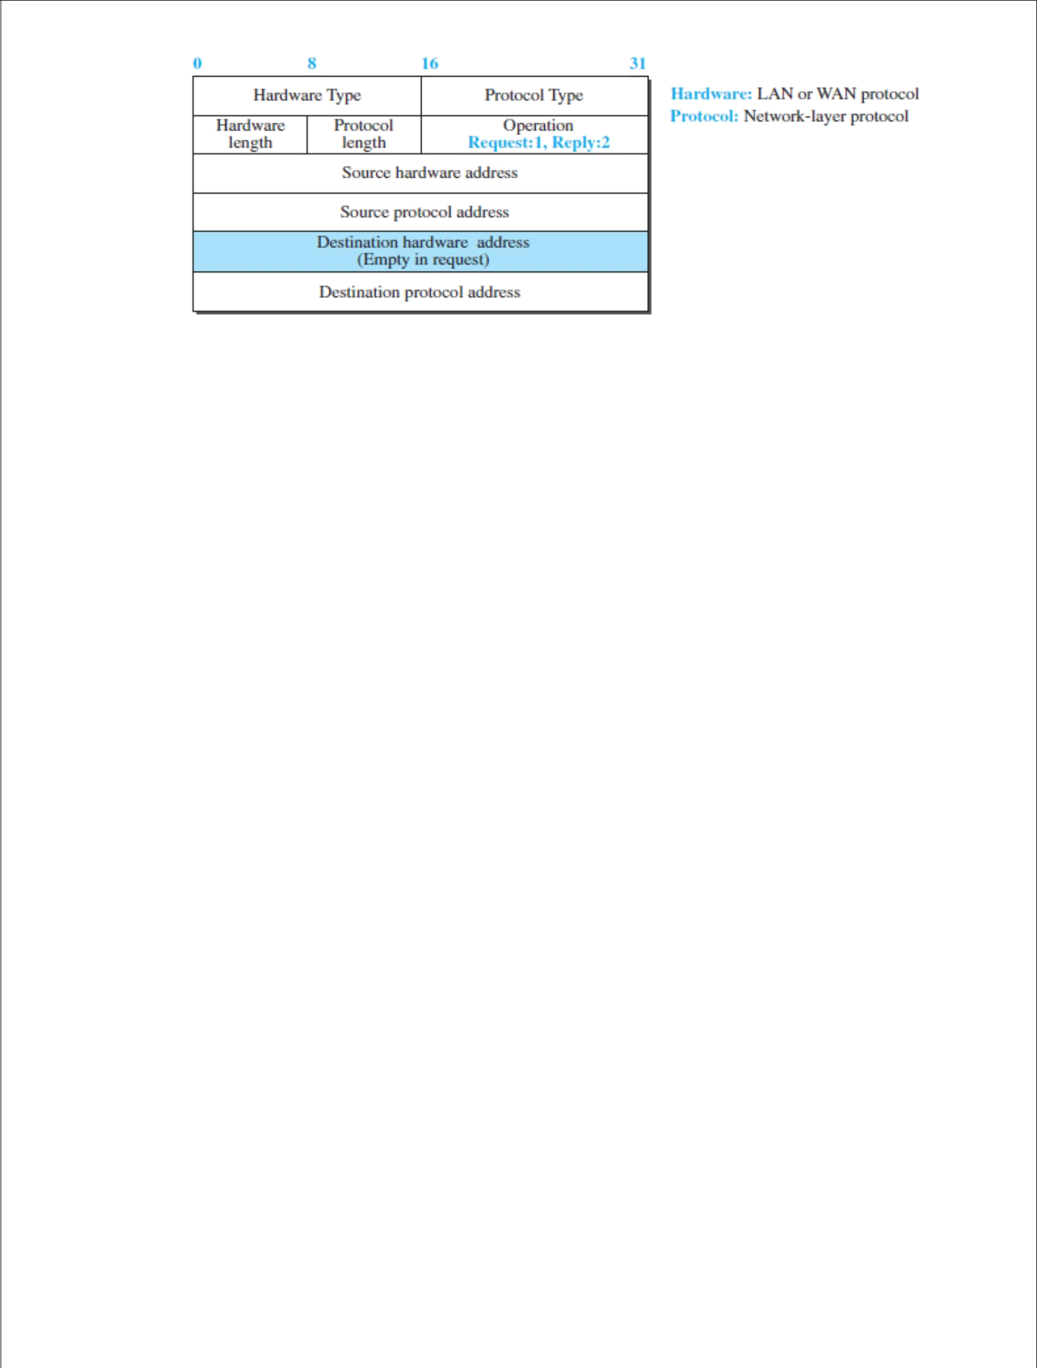

## FIGURE 2.2: ARP PACKET ERROR DETECTION AND CORRECTION:

Networks must be able to transfer data from one device to another with acceptable accuracy. For most applications, a system must guarantee that the data received are identical to the data transmitted.

Any time data are transmitted from one node to the next, they can become corrupted in passage. Many factors can alter one or more bits of a message. Some applications require a mechanism for detecting and correcting **errors.**

Some applications can tolerate a small level of error. For example, random errors in audio or video transmissions may be tolerable, but when we transfer text, we expect a very high level of accuracy.

At the data-link layer, if a frame is corrupted between the two nodes, it needs to be corrected before it continues its journey to other nodes. However, most link-layer protocols simply discard the frame and let the upper-layer protocols handle the retransmission of the frame. Some multimedia applications, however, try to correct the corrupted frame.

## Types of Errors:

Whenever bits flow from one point to another, they are subject to unpredictable changes because of **interference*.*** This interference can change the shape of the signal. The term ***single-bit error*** means that only 1 bit of a given data unit (such as a byte, character, or packet) is changed from 1 to 0 or from 0 to 1.

The term ***burst error*** means that 2 or more bits in the data unit have changed from 1 to 0 or from 0 to 1. Figure 2.3 shows the effect of a single-bit and a burst error on a data unit.

55

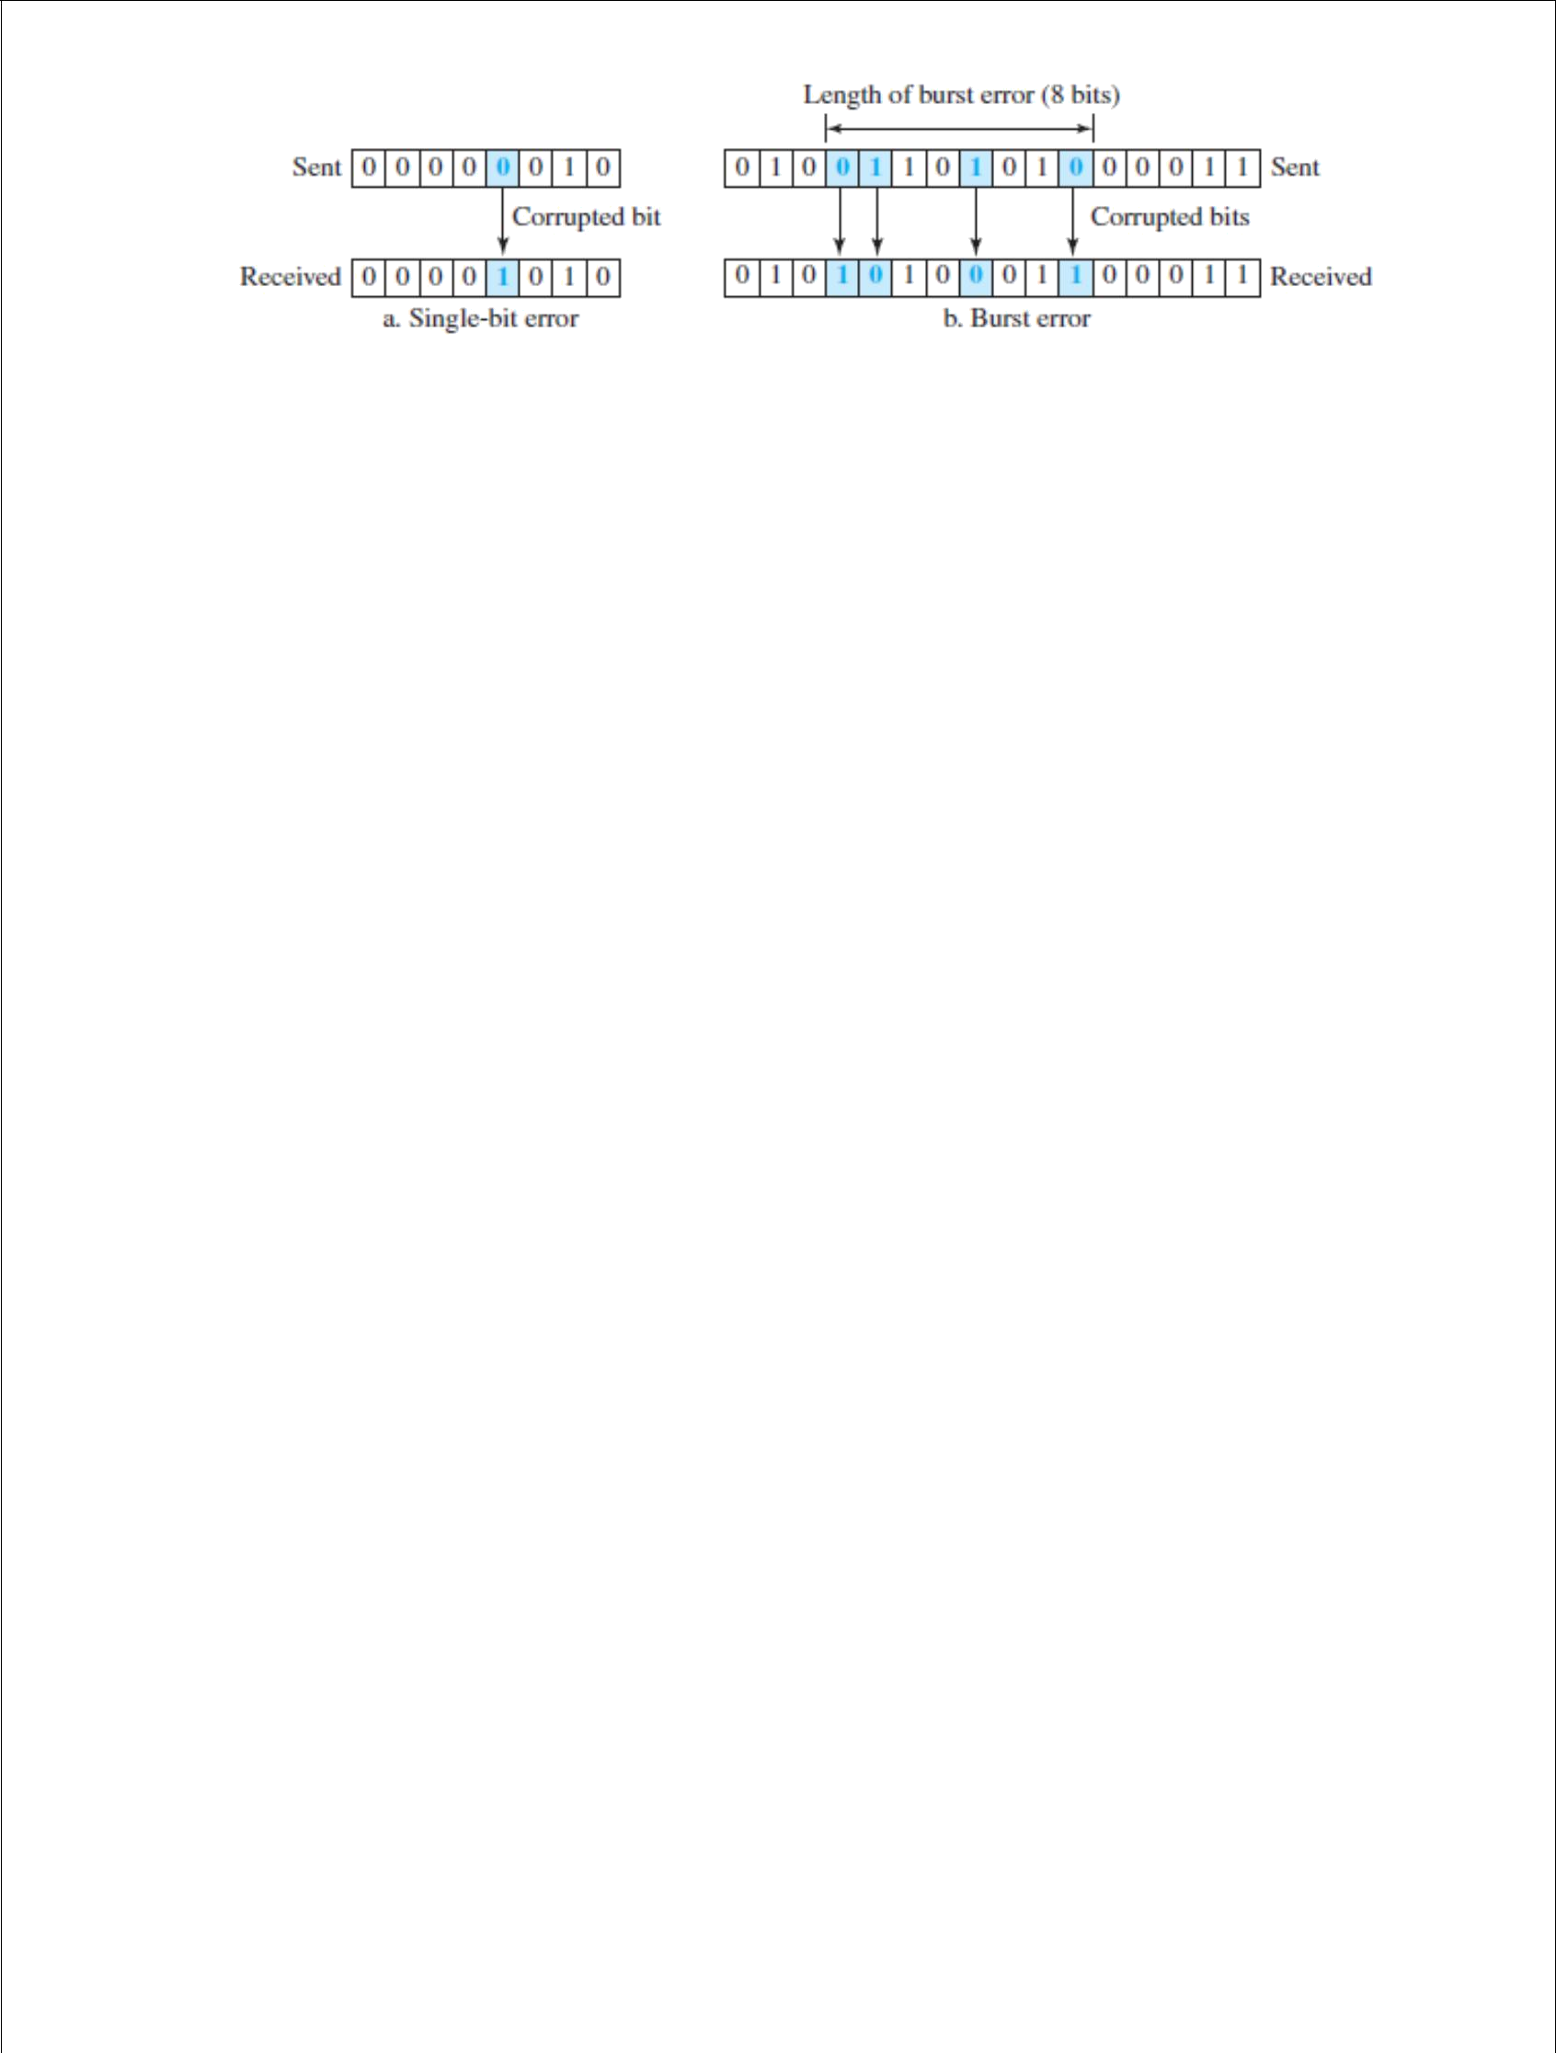

## FIGURE 2.3: SINGLE-BIT AND BURST ERROR

A burst error is more likely to occur than a single-bit error because the duration of the noise signal is normally longer than the duration of 1 bit, which means that when noise affects data, it affects a set of bits.

The number of bits affected depends on the data rate and duration of noise. For example, if we are sending data at 1 kbps, a noise of 1/100 second can affect 10 bits; if we are sending data at 1 Mbps, the same noise can affect 10,000 bits.

## Redundancy:

The central concept in detecting or correcting errors is **redundancy***.* To be able to detect or correct errors, we need to send some extra bits with our data. These redundant bits are added by the sender and removed by the receiver. Their presence allows the receiver to detect or correct corrupted bits.

## Detection versus Correction:

The correction of errors is more difficult than the detection. In **error detection***,* we are only looking to see if any error has occurred. The answer is a simple yes or no. We are not even interested in the number of corrupted bits. A single-bit error is the same for us as a burst error.

In **error correction***,* we need to know the exact number of bits that are corrupted and, more importantly, their location in the message. The number of errors and the size of the message are important factors.

### Hamming Distance:

One of the central concepts in coding for error control is the idea of the Hamming distance. The **Hamming distance** between two words (of the same size) is the number of differences between the corresponding bits. We show the Hamming distance between two words *x* and *y* as ***d***(*x*, *y*). We may wonder why Hamming distance is important for error detection.

The reason is that the Hamming distance between the received codeword and the sent codeword is the number of bits that are corrupted during transmission. For example, if the codeword 00000 is sent and 01101 is received, 3 bits are in error and the Hamming distance between the two is ***d***(00000, 01101) = 3.

56

In other words, if the Hamming distance between the send and the received codeword is not zero, the codeword has been corrupted during transmission.

The Hamming distance can easily be found if we apply the XOR operation (⊕) on the two words and count the number of 1s in the result. Note that the Hamming distance is a value greater than or equal to zero

## CYCLIC CODES:

Cyclic codes are special linear block codes with one extra property. In a **cyclic code,** if a codeword is cyclically shifted (rotated), the result is another codeword. For example, if 1011000 is a codeword and we cyclically left-shift, then 0110001 is also a codeword.

In this case, if we call the bits in the first word *a*0 to *a*6, and the bits in the second word *b*0 to *b*6, we can shift the bits by using the following:



In the rightmost equation, the last bit of the first word is wrapped around and becomes the first bit of the second word.

## Cyclic Redundancy Check:

We can create cyclic codes to correct errors. In this section, we simply discuss a subset of cyclic codes called the **cyclic redundancy check (CRC)**, which is used in networks such as LANs and WANs.

## Advantages of cyclic codes:

We have seen that cyclic codes have a very good performance in detecting single-bit errors, double errors, an odd number of errors, and burst errors.

They can easily be implemented in hardware and software. They are especially fast when implemented in hardware. This has made cyclic codes a good candidate for many networks.

## CHECKSUM:

**Checksum** is an error-detecting technique that can be applied to a message of any length. In the Internet, the checksum technique is mostly used at the network and transport layer rather than the data-link layer.

At the source, the message is first divided into *m*-bit units. The generator then creates an extra *m*-bit unit called the ***checksum,*** which is sent with the message.

At the destination, the checker creates a new checksum from the combination of the message and sent checksum. If the new checksum is all 0s, the message is accepted; otherwise, the message is discarded.

The idea of the traditional checksum is simple. We show this using a simple example.

## Example:

Suppose the message is a list of five 4-bit numbers that we want to send to a destination. In addition to sending these numbers, we send the sum of the numbers. For example, if the set of numbers is (7, 11, 12, 0, 6), we send (7, 11,

12, 0, 6, **36**), where 36 is the sum of the original numbers.

The receiver adds the five numbers and compares the result with the sum. If the two are the same, the receiver assumes no error, accepts the five numbers, and discards the sum. Otherwise, there is an error somewhere and the message is not accepted.

## FORWARD ERROR CORRECTION:

Retransmission of corrupted and lost packets is not useful for real-time multimedia transmission because it creates an unacceptable delay in reproducing: we need to wait until the lost or corrupted packet is resent.

We need to correct the error or reproduce the packet immediately. Several schemes have been designed and used in this case that is collectively referred to as **forward error correction** (FEC) techniques.

## USING HAMMING DISTANCE:

We earlier discussed the Hamming distance for error detection. We said that to detect *s* errors, the minimum Hamming distance should be *d*min = *s* + 1. For error detection, we definitely need more distance.

It can be shown that to detect *t* errors, we need to have *d*min = 2*t* + 1. In other words, if we want to correct 10 bits in a packet, we need to make the minimum hamming distance 21 bits, which means a lot of redundant bits, need to be sent with the data.

## CHUNK INTERLEAVING:

Another way to achieve FEC in multimedia is to allow some small chunks to be missing at the receiver. We cannot afford to let all the chunks belonging to the same packet be missing; however, we can afford to let one chunk be missing in each packet.

Figure 2.4 shows that we can divide each packet into 5 chunks (normally the number is much larger). We can then create data chunk by chunk (horizontally), but combine the chunks into packets vertically. In this case, each packet sent carries a chunk from several original packets. If the packet is lost, we miss only one chunk in each packet, which is normally acceptable in multimedia communication.

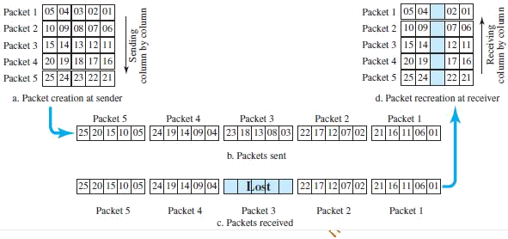**FIGURE 2.4: INTERLEAVING**

# DATA LINK CONTROL

## DLC SERVICES:

The **data link control (DLC)** deals with procedures for communication between two adjacent nodes—node-to-node communication—no matter whether the link is dedicated or broadcast. Data link control functions include *framing* and *flow and error control*.

## FRAMING:

Data transmission in the physical layer means moving bits in the form of a signal from the source to the destination. The physical layer provides bit synchronization to ensure that the sender and receiver use the same bit durations and timing.

The data-link layer, on the other hand, needs to pack bits into frames, so that each frame is distinguishable from another. *Framing* in the data-link layer separates a message from one source to a destination by adding a sender address and a destination address. The destination address defines where the packet is to go; the sender address helps the recipient acknowledge the receipt.

Although the whole message could be packed in one frame, which is not normally done; one reason is that a frame can be very large, making flow and error control very inefficient. When a message is carried in one very large frame, even a single-bit error would require the retransmission of the whole frame. When a

message is divided into smaller frames, a single-bit error affects only that small frame.

### Frame Size:

Frames can be of fixed or variable size. In *fixed-size framing,* there is no need for defining the boundaries of the frames; the size itself can be used as a delimiter.

In variable-size framing, we need a way to define the end of one frame and the beginning of the next. Historically, two approaches were used for this purpose: a character-oriented approach and a bit-oriented approach.

### Character-Oriented Framing:

In *character-oriented (or byte-oriented) framing,* data to be carried are 8-bit characters from a coding system such as ASCII.

The header, which normally carries the source and destination addresses and other control information, and the trailer, which carries error detection redundant bits, are also multiples of 8 bits. Figure 2.5 shows the format of a frame in a character-oriented protocol.

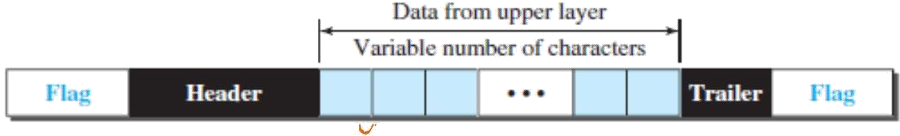

## FIGURE 2.5: A FRAME IN A CHARACTER-ORIENTED PROTOCOL

Character-oriented framing was popular when only text was exchanged by the data-link layers.

However, we send other types of information such as graphs, audio, and video; any character used for the flag could also be part of the information. If this happens, the receiver, when it encounters this pattern in the middle of the data, thinks it has reached the end of the frame.

To fix this problem, a byte-stuffing strategy was added to character-oriented framing. In **byte stuffing** (or character stuffing), a special byte is added to the data section of the frame when there is a character with the same pattern as the flag. The data section is stuffed with an extra byte.

This byte is usually called the *escape character (ESC)* and has a predefined bit pattern. Whenever the receiver encounters the ESC character, it removes it from the data section and treats the next character as data, not as a delimiting flag.

### Bit-Oriented Framing:

In *bit-oriented framing,* the data section of a frame is a sequence of bits to be interpreted by the upper layer as text, graphic, audio, video, and so on. However, in addition to headers (and possible trailers), we still need a delimiter to separate one frame from the other.

Most protocols use a special 8-bit pattern flag, 01111110, as the delimiter to define the beginning and the end of the frame, as shown in Figure 2.6.

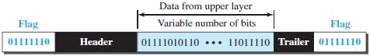

## FIGURE 2.6: A FRAME IN A BIT-ORIENTED PROTOCOL

This flag can create the same type of problem we saw in the character- oriented protocols. That is, if the flag pattern appears in the data, we need to somehow inform the receiver that this is not the end of the frame. We do this by stuffing 1 single bit (instead of 1 byte) to prevent the pattern from looking like a flag. The strategy is called **bit stuffing.**

In bit stuffing, if a 0 and five consecutive 1 bits are encountered, an extra 0 is added. This extra stuffed bit is eventually removed from the data by the receiver.

Note that the extra bit is added after one 0 followed by five 1s regardless of the value of the next bit. This guarantees that the flag field sequence does not inadvertently appear in the frame.

## FLOW AND ERROR CONTROL:

Whenever an entity produces items and another entity consumes them, there should be a balance between production and consumption rates. If the items are produced faster than they can be consumed, the consumer can be overwhelmed and may need to discard some items.

If the items are produced more slowly than they can be consumed, the consumer must wait, and the system becomes less efficient. Flow control is related to the first issue. We need to prevent losing the data items at the consumer site.

In communication at the data-link layer, we are dealing with four entities: network and data-link layers at the sending node and network and data-link layers at the receiving node.

### Buffers:

Although flow control can be implemented in several ways, one of the solutions is normally to use two *buffers*; one at the sending data-link layer and the other at the receiving data-link layer.

A buffer is a set of memory locations that can hold packets at the sender and receiver. The flow control communication can occur by sending signals from the consumer to the producer. When the buffer of the receiving data-link layer is full, it informs the sending data-link layer to stop pushing frames.

### Error Control:

Since the underlying technology at the physical layer is not fully reliable, we need to implement error control at the data-link layer to prevent the receiving node from delivering corrupted packets to its network layer.

Error control at the data-link layer is normally very simple and implemented using one of the following two methods. In both methods, a CRC is added to the frame header by the sender and checked by the receiver.

* In the first method, if the frame is corrupted, it is silently discarded; if it is not corrupted, the packet is delivered to the network layer. This method is used mostly in wired LANs such as Ethernet.
* In the second method, if the frame is corrupted, it is silently discarded; if it is not corrupted, an acknowledgment is sent (for the purpose of both flow and error control) to the sender.

A DLC protocol can be either connectionless or connection-oriented.

### Connectionless Protocol:

In a connectionless protocol, frames are sent from one node to the next without any relationship between the frames; each frame is independent. Note that the term *connectionless* here does not mean that there is no physical connection (transmission medium) between the nodes; it means that there is no *connection* between frames. The frames are not numbered and there is no sense of ordering. Most of the data-link protocols for LANs are connectionless protocols.

### Connection-Oriented Protocol:

In a connection-oriented protocol, a logical connection should first be established between the two nodes (setup phase). After all frames that are somehow related to each other are transmitted (transfer phase), the logical connection is terminated (teardown phase). In this type of communication, the frames are numbered and sent in order.

If they are not received in order, the receiver needs to wait until all frames belonging to the same set are received and then deliver them in order to the

network layer. Connection oriented protocols are rare in wired LANs, but we can see them in some point-to-point protocols, some wireless LANs, and some WANs.

## DATA-LINK LAYER PROTOCOLS:

Traditionally four protocols have been defined for the data-link layer to deal with flow and error control: Simple, Stop-and-Wait, Go-Back-N, and Selective- Repeat. Although the first two protocols still are used at the data-link layer, the last two have disappeared.

**Simple Protocol:** Our first protocol is a **simple protocol** with neither flow nor error control. We assume that the receiver can immediately handle any frame it receives. In other words, the receiver can never be overwhelmed with incoming frames.

The data-link layer at the sender gets a packet from its network layer, makes a frame out of it, and sends the frame. The data-link layer at the receiver receives a frame from the link, extracts the packet from the frame, and delivers the packet to its network layer.

The data-link layers of the sender and receiver provide transmission services for their network layers.

**Stop-and-Wait Protocol:** Our second protocol is called the **Stop-and-Wait protocol,** which uses both flow and error control. In this protocol, the sender sends one frame at a time and waits for an acknowledgement before sending the next one. To detect corrupted frames, we need to add a CRC to each data frame.

When a frame arrives at the receiver site, it is checked. If its CRC is incorrect, the frame is corrupted and silently discarded. The silence of the receiver is a signal for the sender that a frame was either corrupted or lost.

Every time the sender sends a frame, it starts a timer. If an acknowledgment arrives before the timer expires, the timer is stopped and the sender sends the next frame (if it has one to send). If the timer expires, the sender resends the previous frame, assuming that the frame was either lost or corrupted.

This means that the sender needs to keep a copy of the frame until its acknowledgment arrives. When the corresponding acknowledgment arrives, the sender discards the copy and sends the next frame if it is ready.

## Piggybacking:

The two protocols we discussed in this section are designed for unidirectional communication, in which data is flowing only in one direction although the acknowledgment may travel in the other direction.

Protocols have been designed in the past to allow data to flow in both directions. However, to make the communication more efficient, the data in one direction is piggybacked with the acknowledgment in the other direction.

In other words, when node A is sending data to node B, Node A also acknowledges the data received from node B. Because piggybacking makes communication at the data link layer more complicated, it is not a common practice.

## HDLC:

**High-level Data Link Control (HDLC)** is a bit-oriented protocol for communication over point-to-point and multipoint links. It implements the Stop- and-Wait protocol.

## Configurations and Transfer Modes:

HDLC provides two common transfer modes that can be used in different configurations: *normal response mode (NRM)* and *asynchronous balanced mode (ABM)*. In *normal response mode (NRM)*, the station configuration is unbalanced.

We have one primary station and multiple secondary stations. A *primary station* can send commands; a *secondary station* can only respond. The NRM is used for both point-to-point and multipoint links, as shown in Figure 2.7.

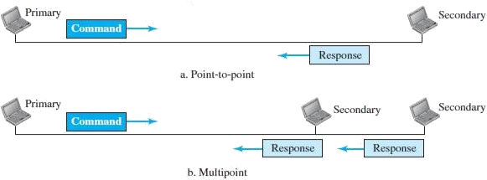

## FIGURE 2.7: NORMAL RESPONSE MODE

In ABM, the configuration is balanced. The link is point-to-point, and each station can function as a primary and a secondary (acting as peers), as shown in Figure 2.8. This is the common mode today.

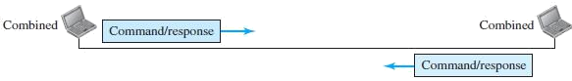

## FIGURE 2.8: ASYNCHRONOUS BALANCED MODE

To provide the flexibility necessary to support all the options possible in the modes and configurations just described, HDLC defines three types of frames: *information frames (I-frames)*, *supervisory frames (S-frames)*, and *unnumbered frames (U-frames)*.

Each type of frame serves as an envelope for the transmission of a different type of message. I-frames are used to data-link user data and control information relating to user data (piggybacking).

S-frames are used only to transport control information. U-frames are reserved for system management. Information carried by U-frames is intended for managing the link itself.

Each frame in HDLC may contain up to six fields, as shown in Figure 2.9: a beginning flag field, an address field, a control field, an information field, a frame check sequence (FCS) field, and an ending flag field. In multiple-frame transmissions, the ending flag of one frame can serve as the beginning flag of the next frame.

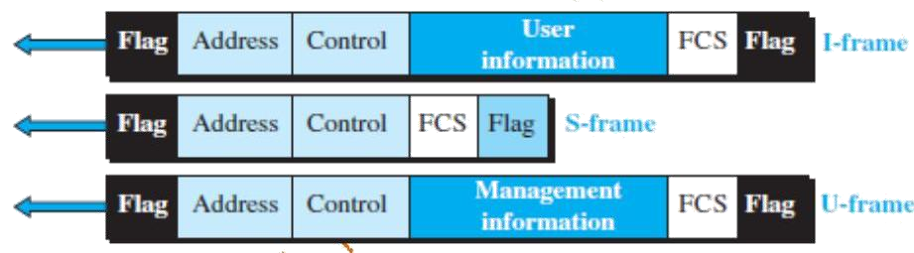

## FIGURE 2.9: HDLC FRAMES

* ***Flag field.*** This field contains synchronization pattern 01111110, which identifies both the beginning and the end of a frame.
* ***Address field.*** This field contains the address of the secondary station. If a primary station created the frame, it contains *to* address. If a secondary station creates the frame, it contains *from* address. The address field can be one byte or several bytes long, depending on the needs of the network.
* ***Control field.*** The control field is one or two bytes used for flow and error control.
* ***Information field.*** The information field contains the user‘s data from the network layer or management information. Its length can vary from one network to another.
* ***FCS field.*** The frame check sequence (FCS) is the HDLC error detection field. It can contain either a 2- or 4-byte CRC.

## POINT-TO-POINT PROTOCOL (PPP):

One of the most common protocols for point-to-point access is the **Point-to- Point Protocol (PPP).** Today, millions of Internet users who need to connect their home computers to the server of an Internet service provider use PPP.

The majority of these users have a traditional modem; they are connected to the Internet through a telephone line, which provides the services of the physical layer. But to control and manage the transfer of data, there is a need for a point- to-point protocol at the data-link layer. PPP is by far the most common.

## Services provided by PPP:

PPP defines the format of the frame to be exchanged between devices. It also defines how two devices can negotiate the establishment of the link and the exchange of data. PPP is designed to accept payloads from several network layers (not only IP).

Authentication is also provided in the protocol, but it is optional. The new version of PPP, called *Multilink PPP,* provides connections over multiple links. One interesting feature of PPP is that it provides network address configuration. This is particularly useful when a home user needs a temporary network address to connect to the Internet.

## Services Not Provided by PPP:

PPP does not provide flow control. A sender can send several frames one after another with no concern about overwhelming the receiver. PPP has a very simple mechanism for error control. A CRC field is used to detect errors.

If the frame is corrupted, it is silently discarded; the upper-layer protocol needs to take care of the problem. Lack of error control and sequence numbering may cause a packet to be received out of order. PPP does not provide a sophisticated addressing mechanism to handle frames in a multipoint configuration.

## Framing:

PPP uses a character-oriented (or byte-oriented) frame. Figure 2.10 shows the format of a PPP frame. The description of each field follows:

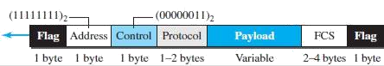

## FIGURE 2.10: PPP FRAME FORMAT

* ***Flag.*** A PPP frame starts and ends with a 1-byte flag with the bit pattern 01111110.
* ***Address.*** The address field in this protocol is a constant value and set to 11111111 (broadcast address).
* ***Control.*** This field is set to the constant value 00000011 (imitating unnumbered frames in HDLC).
* ***Protocol.*** The protocol field defines what is being carried in the data field: either user data or other information. This field is by default 2 bytes long, but the two parties can agree to use only 1 byte.
* ***Payload field.*** The data field is a sequence of bytes with the default of a maximum of 1500 bytes; but this can be changed during negotiation.
  + The data field is byte-stuffed if the flag byte pattern appears in this field.
  + Because there is no field defining the size of the data field, padding is needed if the size is less than the maximum default value or the maximum negotiated value.
* ***FCS.*** The frame check sequence (FCS) is simply a 2-byte or 4-byte standard CRC.

# MEDIA ACCESS CONTROL (MAC)

When nodes or stations are connected and use a common link, called a *multipoint* or *broadcast link,* we need a multiple-access protocol to coordinate access to the link. The problem of controlling the access to the medium is similar to the rules of speaking in an assembly.

Many protocols have been devised to handle access to a shared link. All of these protocols belong to a sub layer in the data-link layer called *media access control (MAC).* We categorize them into three groups, as shown in Figure 2.11.

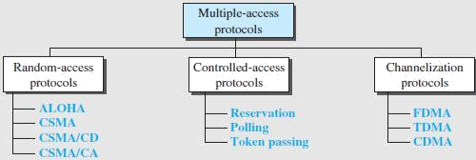

## FIGURE 2.11: TAXONOMY OF MULTIPLE-ACCESS PROTOCOLS RANDOM ACCESS:

In **random-access** or **contention** methods, no station is superior to another station and none is assigned control over another. At each instance, a station that has data to send uses a procedure defined by the protocol to make a decision on whether or not to send.

This decision depends on the state of the medium (idle or busy). Two features give this method its name.

* First, there is no scheduled time for a station to transmit. Transmission is random among the stations. That is why these methods are called *random access*.
* Second, no rules specify which station should send next. Stations compete with one another to access the medium. That is why these methods are also called *contention* methods.

In a random-access method, each station has the right to the medium without being controlled by any other station. However, if more than one station tries to send, there is an access conflict—***collision***—and the frames will be either destroyed or modified. To avoid access conflict or to resolve it when it happens, each station follows a procedure that answers the following questions:

* + When can the station access the medium?
  + What can the station do if the medium is busy?
  + How can the station determine the success or failure of the transmission?
  + What can the station do if there is an access conflict?

The random-access methods have evolved from a very interesting protocol known as *ALOHA*, which used a very simple procedure called ***multiple access (MA).***

ALOHA is basically a multiple access protocol which describes how all the terminals can access a medium without interfering at all with one another or even colliding. It operates at the data-link layer. Roberts created a protocol in 1972 that would double the capacity of ALOHA. The Slotted ALOHA protocol divides the time interval into discrete slots, each of which is equal to one frame’s worth of time. To avoid collisions, this approach needs synchronization between the sending nodes.

**Versions of ALOHA**

**Pure ALOHA**

The total time of transmission is continuous in pure ALOHA. A station sends a frame whenever one is available. The sender waits for an arbitrary period of time before retransmitting the frame if there is a collision and it is destroyed.

**In**pure ALOHA, the stations transmit frames whenever they have data to send.

• When two or more stations transmit simultaneously, there is collision and the frames are destroyed.

• In pure ALOHA, whenever any station transmits a frame, it expects the acknowledgement from the receiver.

• If acknowledgement is not received within specified time, the station assumes that the frame (or acknowledgement) has been destroyed.

• If the frame is destroyed because of collision the station waits for a random amount of time and sends it again. This waiting time must be random otherwise same frames will collide again and again.

• Therefore pure ALOHA dictates that when time-out period passes, each station must wait for a random amount of time before re-sending its frame. This randomness will help avoid more collisions.

• Figure shows an example of frame collisions in pure ALOHA.

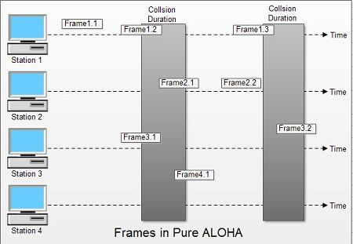

• In fig there are four stations that contended with one another for access to shared channel. All these stations are transmitting frames. Some of these frames collide because multiple frames are in contention for the shared channel. Only two frames, frame 1.1 and frame 2.2 survive. All other frames are destroyed.

• Whenever two frames try to occupy the channel at the same time, there will be a collision and both will be damaged. If first bit of a new frame overlaps with just the last bit of a frame almost finished, both frames will be totally destroyed and both will have to be retransmitted.

**Slotted ALOHA**

Slotted ALOHA increases the capacity of pure ALOHA while reducing collisions. Slots are discrete time periods that are used to divide up the shared channel. Only at the start of each time slot is the station able to transmit data. If multiple stations attempt to transmit at the start of the same time slot, there may still be collisions.

The method was improved with the addition of a procedure that forces the station to sense the medium before transmitting. This was called *carrier sense multiple access* (*CSMA*). This method later evolved into two parallel methods: *carrier sense multiple access with collision detection (CSMA/CD),* which tells the station what to do when a collision is detected, and *carrier sense multiple access with collision avoidance (CSMA/CA),* which tries to avoid the collision.

Slotted ALOHA was invented to improve the efficiency of pure ALOHA as chances of collision in pure ALOHA are very high.

• In slotted ALOHA, the time of the shared channel is divided into discrete intervals called slots.

• The stations can send a frame only at the beginning of the slot and only one frame is sent in each slot.

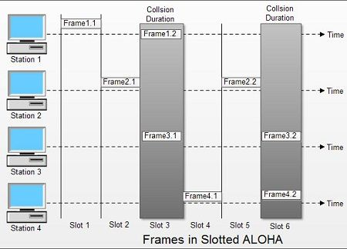

• In slotted ALOHA, if any station is not able to place the frame onto the channel at the beginning of the slot *i.e.*it misses the time slot then the station has to wait until the beginning of the next time slot.

• In slotted ALOHA, there is still a possibility of collision if two stations try to send at the beginning of the same time slot as shown in fig.

• Slotted ALOHA still has an edge over pure ALOHA as chances of collision are reduced to one-half.

## Protocol Flow Chart for ALOHA

                              Fig. shows the protocol flow chart for ALOHA.

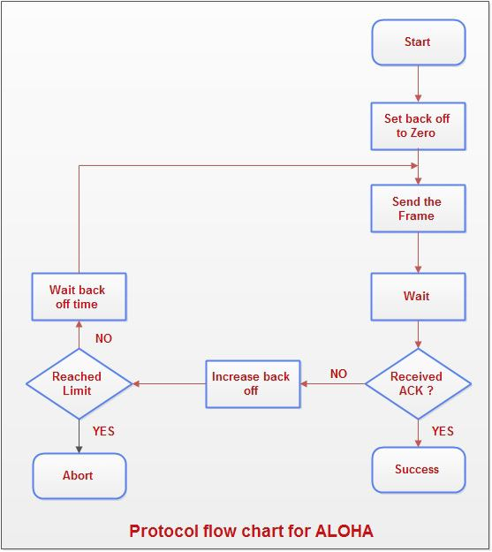

**Explanation:**

• A station which has a frame ready will send it.

• Then it waits for some time.

• If it receives the acknowledgement then the transmission is successful.

• Otherwise the station uses a backoff strategy, and sends the packet again.

• After many times if there is no acknowledgement then the station aborts the idea of transmission.

**Differences between ALOHA and Slotted ALOHA**

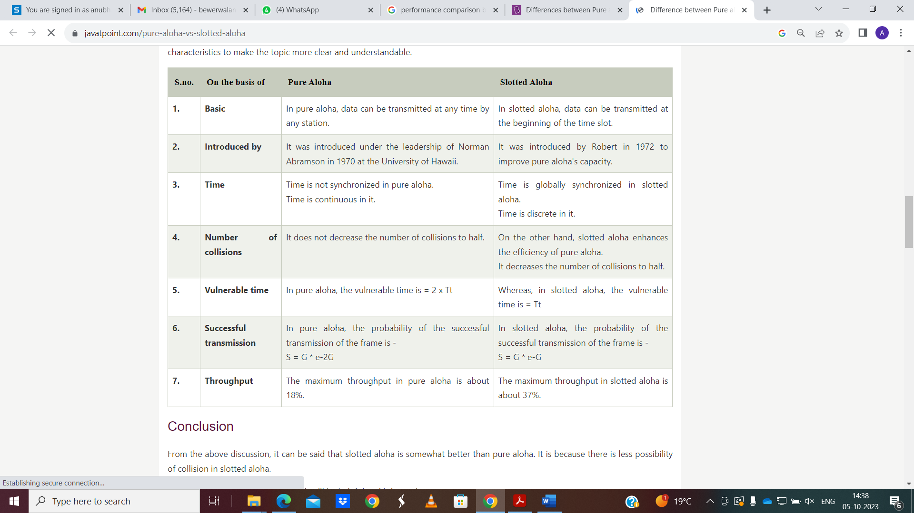

# Derive the efficiency of Pure ALOHA protocol

The efficiency of an ALOHA system is that fraction of all transmitted frames which escape collisions that is which do not get caught in collisions.  
Consider ∞ number of interactive users at their computers (stations). Each user is either typing or waiting. Initially, all of them are in the typing state. When a user types a line, the user stops and waits. The station then transmits a frame containing this line and checks the channel to confirm the success. If it is successful then the user will start typing again, otherwise, the user waits and its frame is retransmitted much time till it is sent successfully.

**Frame time :**  
Let the frame time be defined as the amount of time required to transmit the standard fixed length frame.  
Note that ***Frame time = Frame length/Bit rate***

We assume that ∞ number of users generates new frames according to Poisson’s distribution with an average N frame per frame time. The value of N > 1 indicates that the users are generating frames at a rate higher than that can be handled by the channel. So most of the frames will face collision.   
Hence  0 <N <1 in order to reduce the number of collisions. Let there be k transmission attempts (including retransmissions) per frame time.  The probability of k transmissions per frame time is also Poisson.

Let the mean number of transmissions be **G** per frame time.  So, **G≥N**. At low load N ≈ 0 there will be fewer collisions so less number of retransmissions and G ≈ N. With the increase in load  there are many collisions so G > N. Combining all these we can say that for all the loads the throughput is given by,

**P0*=S/G*(Fraction of attempted frames that are transmitted successfully )**  
***S = GP* (throughput per frame time)**

Where P’ = Probability that a frame does not suffer a collision.

## 

**What is the condition for frame 3 in Fig. to arrive undamaged without collision?**

Let *t = time required* to send a frame. If frame 1 is generated at any instant between t0 to (t0 + t) then it will collide with frame 3, Similarly, any frame 2 generated between (t0 + 1) and (t + 2t) also collides with frame 3. As per Poisson’s distribution, the Probability of Generating k frames during a given frame time is given by

**P[k] = [ Gk x e(-G) ]/k!  (Poisson’s distribution)**  
Where G = Number of stations willing to transmit data

So the probability of generating zero frames i.e. k= 0 is 3.

**P[k]=[ G0 x e(-G) ]/0!**  
**P[k]= e-2G**

If an interval is two frame time long, the mean number of frames generated during that interval is 2G. The probability that another frame is transmitted during the Vulnerable period (the time when a collision can take place) is,

**P0= e-2G**  
Fig. shows the relation between the offered traffic G and the throughput S. It shows that the maximum throughput occurs at **G = 0.5**   
**S= 0.5 x e-2 x 0.5**  
**= 0.5 x e-1**  
**= 0.184**  
**= 18.4%**

S(max) = 0.184. So the best possible channel utilization is 18.4%. It means 82% of frames end up in collisions and are therefore lost.

## CONTROLLED ACCESS:

In **controlled access,** the stations consult one another to find which station has the right to send. A station cannot send unless it has been authorized by other stations. There are three controlled-access methods:

**Reservation:** In the **reservation** method, a station needs to make a reservation before sending data. Time is divided into intervals. In each interval, a reservation frame precedes the data frames sent in that interval.

If there are *N* stations in the system, there are exactly *N* reservation minislots in the reservation frame. Each minislot belongs to a station. When a station needs to send a data frame, it makes a reservation in its own minislot.

The stations that have made reservations can send their data frames after the reservation frame. Figure 2.12 shows a situation with five stations and a five- minislot reservation frame. In the first interval, only stations 1, 3, and 4 have made reservations. In the second interval, only station 1 has made a reservation.

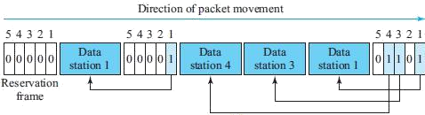

## FIGURE 2.12: RESERVATION ACCESS METHOD

**Polling: Polling** works with topologies in which one device is designated as a ***primary station*** and the other devices are ***secondary stations*.** All data exchanges must be made through the primary device even when the ultimate destination is a secondary device.

The primary device controls the link; the secondary devices follow its instructions. It is up to the primary device to determine which device is allowed to use the channel at a given time.

The primary device, therefore, is always the initiator of a session (see Figure 2.13). This method uses poll and select functions to prevent collisions. However, the drawback is if the primary station fails, the system goes down.

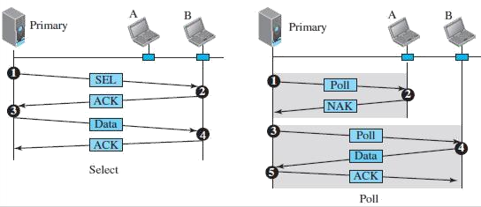

## FIGURE 2.13: SELECT & POLL FUNCTIONS IN POLLING-ACCESS

**METHOD**

***Select:*** The *select* function is used whenever the primary device has something to send. Before sending data, the primary creates and transmits a select (SEL) frame, one field of which includes the address of the intended secondary.

***Poll:*** The *poll* function is used by the primary device to solicit transmissions from the secondary devices. When the primary is ready to receive data, it must ask (poll) each device in turn if it has anything to send.

When the first secondary is approached, it responds either with a NAK frame if it has nothing to send or with data (in the form of a data frame) if it does. If the response is negative (a NAK frame), then the primary polls the next secondary in the same manner until it finds one with data to send.

When the response is positive (a data frame), the primary reads the frame and returns an acknowledgment (ACK frame), verifying its receipt.

**Token Passing:** In the **token-passing** method, the stations in a network are organized in a logical ring. In other words, for each station, there is a ***predecessor*** and a ***successor***.

The ***predecessor*** is the station which is logically before the station in the ring; the ***successor*** is the station which is after the station in the ring. The current station is the one that is accessing the channel now. The right to this access has been passed from the predecessor to the current station. The right will be passed to the successor when the current station has no more data to send.

But how is the right to access the channel passed from one station to another? In this method, a special packet called a ***token*** circulates through the ring.

The possession (*meaning control*) of the token gives the station the right to access the channel and send its data. When a station has some data to send, it waits until it receives the token from its predecessor.

It then holds the token and sends its data. When the station has no more data to send, it releases the token, passing it to the next logical station in the ring. The station cannot send data until it receives the token again in the next round. In this process, when a station receives the token and has no data to send, it just passes the data to the next station.

# CHANNELIZATION:

**Channelization** (or *channel partition,* as it is sometimes called) is a multiple-access method in which the available bandwidth of a link is shared in time,

frequency, or through code, among different stations. There are three channelization protocols: ***FDMA***, ***TDMA***, and ***CDMA***.

## FDMA:

In **frequency-division multiple access (FDMA),** the available bandwidth is divided into frequency bands. Each station is allocated a band to send its data. In other words, each band is reserved for a specific station, and it belongs to the station all the time.

Each station also uses a band pass filter to confine the transmitter frequencies. To prevent station interferences, the allocated bands are separated from one another by small *guard bands.*

FDMA specifies a predetermined frequency band for the entire period of communication. This means that stream data (a continuous flow of data that may not be packetized) can easily be used with FDMA.

We need to emphasize that although FDMA and frequency-division multiplexing (FDM) conceptually seem similar, there are differences between them.

FDM is a physical layer technique that combines the loads from low bandwidth channels and transmits them by using a high-bandwidth channel.

FDMA, on the other hand, is an access method in the data-link layer. The datalink layer in each station tells its physical layer to make a bandpass signal from the data passed to it. The signal must be created in the allocated band.

## TDMA:

In **time-division multiple access (TDMA),** the stations share the bandwidth of the channel in time. Each station is allocated a time slot during which it can send data. Each station transmits its data in its assigned time slot.

The main problem with TDMA lies in achieving synchronization between the different stations. Each station needs to know the beginning of its slot and the location of its slot. This may be difficult because of propagation delays introduced in the system if the stations are spread over a large area.

To compensate for the delays, we can insert *guard times*. Synchronization is normally accomplished by having some synchronization bits (normally referred to as *preamble bits*) at the beginning of each slot.

We also need to emphasize that although TDMA and time-division multiplexing (TDM) conceptually seem the same, there are differences between them.

TDM is a physical layer technique that combines the data from slower channels and transmits them by using a faster channel. The process uses a physical multiplexer that interleaves data units from each channel.

TDMA, on the other hand, is an access method in the data-link layer. The data-link layer in each station tells its physical layer to use the allocated time slot. There is no physical multiplexer at the physical layer.

## CDMA:

**Code-division multiple access (CDMA)** was conceived (*meaning imagine/visualize*) several decades ago. Recent advances in electronic technology have finally made its implementation possible.

CDMA differs from FDMA in that only one channel occupies the entire bandwidth of the link. It differs from TDMA in that all stations can send data simultaneously; there is no timesharing. In CDMA, one channel carries all transmissions simultaneously.

# CONNECTING DEVICES AND VIRTUAL LAN’S

Hosts or LANs do not normally operate in isolation. They are connected to one another or to the Internet. To connect hosts or LANs, we use connecting devices. Connecting devices can operate in different layers of the Internet model.

## CONNECTING DEVICES:

Hosts and networks do not normally operate in isolation. We use **connecting devices** to connect hosts **together** to make a network or to connect networks together to make an internet. Connecting devices can operate in different layers of the Internet model.

We discuss three kinds of *connecting devices:* ***hubs***, ***link-layer switches***, and ***routers***.

Hubs today operate in the first layer of the Internet model. Link-layer switches operate in the first two layers. Routers operate in the first three layers. (See Figure 2.14)

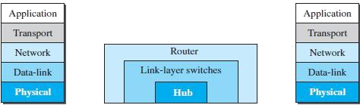

## FIGURE 2.14: THREE CATEGORIES OF CONNECTING DEVICES

**HUBS:** A **hub** is a device that operates only in the physical layer. Signals that carry information within a network can travel a fixed distance before attenuation endangers the integrity of the data. A **repeater** receives a signal and, before it becomes too weak or corrupted, *regenerates* and *retimes* the original bit pattern.

The repeater then sends the refreshed signal. In the past, when Ethernet LANs were using bus topology, a repeater was used to connect two segments of a LAN to overcome the length restriction of the coaxial cable. Today, however, Ethernet LANs use star topology.

In a star topology, a repeater is a multiport device, often called a *hub that* can be used to serve as the connecting point and at the same time function as a repeater.

Figure 2.15 shows that when a packet from station A to station B arrives at the hub, the signal representing the frame is regenerated to remove any possible corrupting noise, but the hub forwards the packet from all outgoing ports except The one from which the signal was received

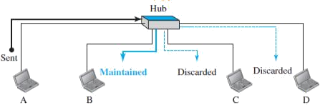

## FIGURE 2.15: A HUB

In other words, the frame is broadcast. All stations in the LAN receive the frame, but only station B keeps it. The rest of the stations discard it. Figure 2.15 shows the role of a repeater or a hub in a switched LAN. A repeater has no filtering capability.

A hub or a repeater is a physical-layer device. They do not have a link-layer address and they do not check the link-layer address of the received frame. They just regenerate the corrupted bits and send them out from every port.

**Link-Layer Switches:** A **link-layer switch** (or ***switch***) operates in both the physical and the data-link layers. As a physical-layer device, it regenerates the signal it receives. As a link-layer device, the link-layer switch can check the MAC addresses (source and destination) contained in the frame.

### Filtering:

One may ask what the difference in functionality is between a link-layer switch and a hub. A link-layer switch has **filtering** capability. It can check the destination address of a frame and can decide from which outgoing port the frame should be sent. A link-layer switch has a table used in filtering decisions.

In Figure 2.16, we have a LAN with four stations that are connected to a link- layer switch. If a frame destined for station 71:2B:13:45:61:42 arrives at port 1, the link-layer switch consults its table to find the departing port.

According to its table, frames for 71:2B:13:45:61:42 should be sent out only through port 2; therefore, there is no need for forwarding the frame through other ports.

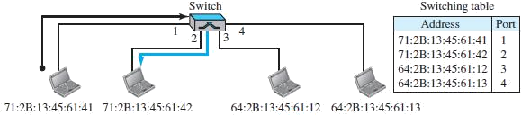

# FIGURE 2.16: LINK-LAYER SWITCH

A Link-Layer Switch does not change the Link-Layer (MAC) addresses in a frame.

***Transparent Switches:***

A **transparent switch is** a switch in which the stations are completely unaware of the switch‘s existence. If a switch is added or deleted from the system, reconfiguration of the stations is unnecessary.

***Advantages of Switches:*** A link-layer switch has several advantages over a hub. We discuss only two of them here.

***Collision Elimination:*** This means increasing the average bandwidth available to a host in the network. In a switched LAN, there is no need for carrier sensing and collision detection; each host can transmit at any time.

***Connecting Heterogeneous Devices:*** A link-layer switch can connect devices that use different protocols at the physical layer (data rates) and different transmission media.

# ROUTERS:

A **router** is a three-layer device; it operates in the physical, data-link, and network layers. As a physical-layer device, it regenerates the signal it receives. As a link-layer device, the router checks the physical addresses (source and

destination) contained in the packet. As a network-layer device, a router checks the network-layer addresses.

A router can connect networks. In other words, a router is an internetworking device; it connects independent networks to form an internetwork. According to this definition, two networks connected by a router become an internetwork or an internet.

There are three major differences between a router and a repeater or a switch.

1. A router has a physical and logical (IP) address for each of its interfaces.
2. A router acts only on those packets in which the link-layer destination address matches the address of the interface at which the packet arrives.
3. A router changes the link-layer address of the packet (both source and destination) when it forwards the packet.

# VIRTUAL LANS:

A station is considered part of a LAN if it physically belongs to that LAN. The criterion of membership is geographic. What happens if we need a virtual connection between two stations belonging to two different physical LANs? We can roughly define a **virtual local area network (VLAN)** as a local area network configured by software, not by physical wiring.

The whole idea of VLAN technology is to divide a LAN into logical, instead of physical, segments. A LAN can be divided into several logical LANs, called *VLANs.*

Each VLAN is a work group in the organization. If a person moves from one group to another, there is no need to change the physical configuration. The group membership in VLANs is defined by software, not hardware. Any station can be logically moved to another VLAN.

All members belonging to a VLAN can receive broadcast messages sent to that particular VLAN.

VLAN technology even allows the grouping of stations connected to different switches in a VLAN.

**DEPARTMENT OF COMPUTER SCIENCE & ENGINEERING**

**ACADEMIC SESSION: ODD SEMESTER (2023-24)**

**Assignment No. 1 (Unit-2)**

**Name of Subject: Computer Networks-II (TCS 703) Course: B.Tech.**

**Branch: CSE Semester: VII**

**Date of Issue: Date of Submission:**

**Instructions:**

1. **Use A-4 sized blank pages.**

**2. Submit the hard-copy to the subject-teacher. Create the PDF of the assignment submitted and keep it with you for knowledge.**

**3. Attempt all questions. Each question carries equal marks.**

**Questions:**

1. Discuss the following in brief.

i) Explain functionality of ARP and RARP..

ii) Compare and contrast CSMA/CD with CSMA/CA.

1. Which of the following CRC generators guarantee the detection of a Single Bit Error:
2. x + 1
3. x2 + 1
4. Compare Aloha with Slotted Aloha. Measurement of slotted ALOHA channel with infinite number of users show that the l0 percent of slots are idle.

(i) What is the channel toad?

(ii) What is the throughput?

1. State the requirements of CRC. A bit-stream 10011101 is transmitted using x3 + 1 generator polynomial. Generate the CRC code word for this message.
2. A series of 8-bit message blocks (frames) is to be transmitted across a data link using a CRC for error detection. A generator polynomial of 11001 is to be used. Use an example to illustrate the following:
3. The CRC generation process
4. The CRC checking process.